AUTHORITY TO SELL

Date: _______________

TO: Michele A. Romarate
Real Estate Broker

I hereby give you, from this date and for such further periods as I may authorize to negotiate for the sale of the following described property, subject to the terms and conditions herein stated:

Lot # :
OCT# :
Location :
Area :
Price : ________________
Expenses :
Commission :
Period of :
Authority :
Remarks:
*Should the sale be made or affected on modified terms or such other terms as may be accepted by me, you are likewise credited for the said sale and shall be given the above-mentioned professional fee based on the revised/agreed price.
*You are not authorized to receive payment on my behalf from your buyers, nor bind the undersigned by any contract without subsequent specific authority.

CONFORME:
________________________
OWNER/REPRESENTATIVE
Signature over printed name

Michele A. Romarate, REB
Broker/Manager
PRC License No. 0028571
HLURB License No. 02926

Date: _____________ _________________________
Address/Telephone. No.

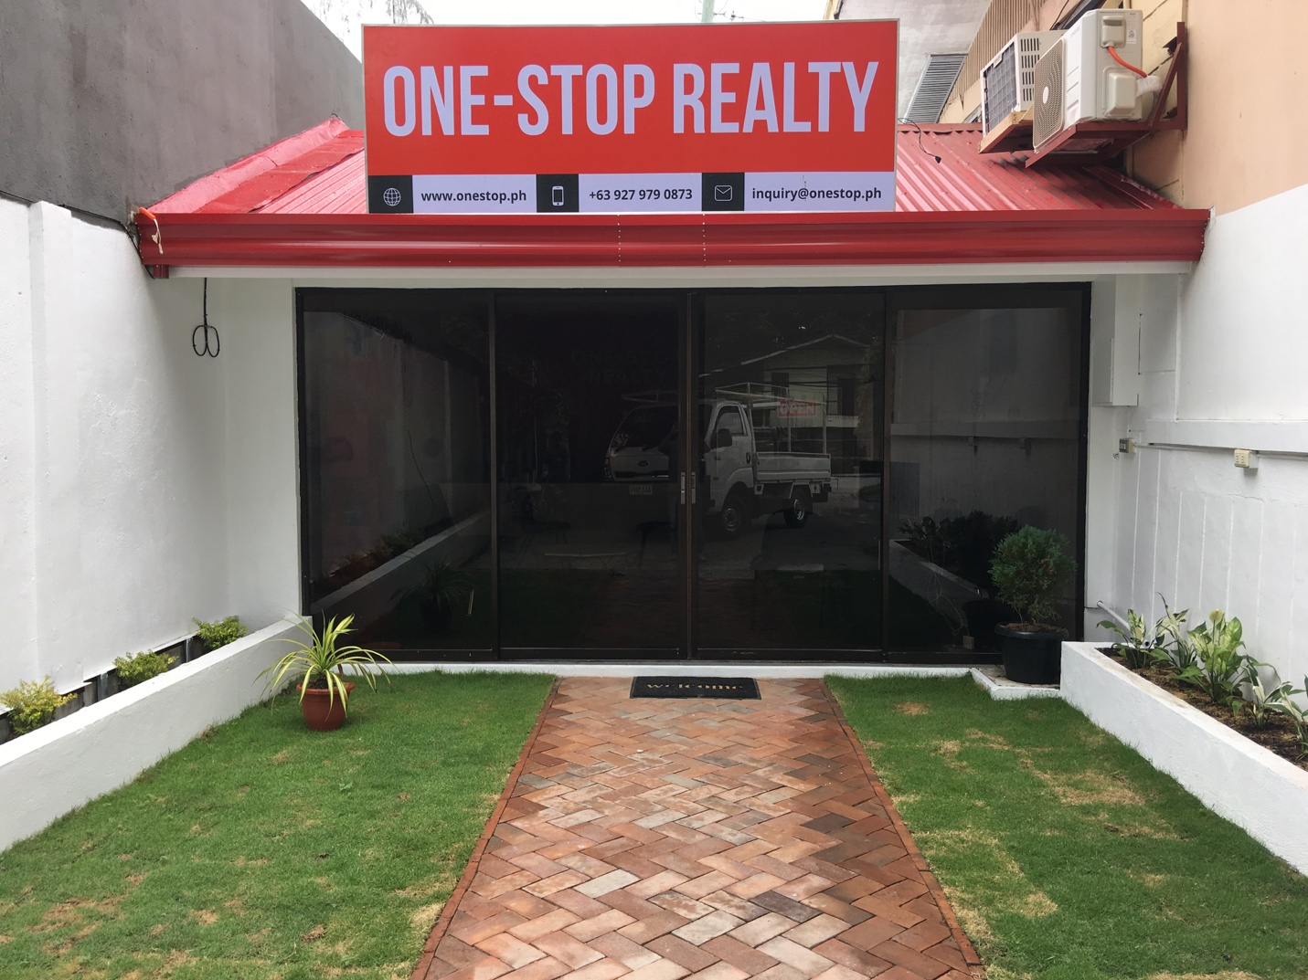

COMPANY PROFILE

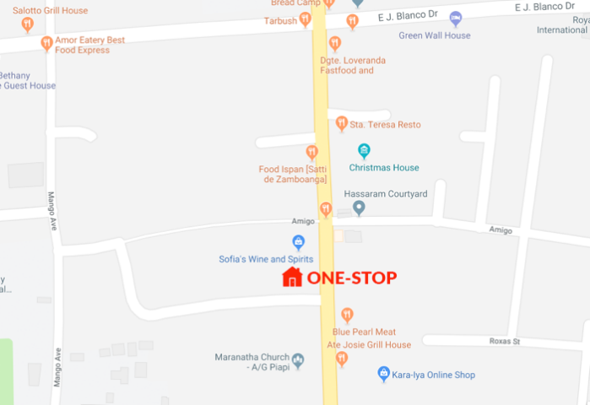
EZ One-stop Realty is a newly established real estate company based in Dumaguete City. Its name is derived from its commitment to provide a full-stack service for all real estate-related transactions and needs. Essentially being a “one-stop hub” realty.

EZ One-stop Realty is committed to helping its pool of sales agents get the training, mentorship and experience to succeed in the real estate industry in terms of making sales, handling clients and after-sale support.

We are also committed to making sure that our clients get the best deals available in the Real Estate industry, providing end-to-end support, excellent service and client satisfaction. We strive to meet client requirements and expectations to ensure that we maintain confidence and standards set by the realty.

